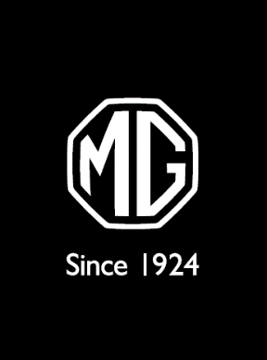
cmd

16 October 2025

MG FOURWAYS
MG’s Latest Flagship Opens its Doors

Fast Facts:

- Official opening – 1 October 2025
- 48th MG Dealership in SA
- Flagship Dealership
- Newest addition to the MG family
- Part of Phase V Automotive Group – 13 dealerships plus approved repair centres + The Car Auction (online auction platform)
- MG Fourways – 35 staff employed on-site
- Matthew Vermaak, Managing Director, Phase V Automotive: “MG Fourways isn’t just another dealership – it’s the right move at the right time. We’re proud to add MG to the Phase V family, now with two dealerships – MG Sandton and MG Fourways. MG fits how South Africans live today: smart, stylish, and affordable, and we’re excited to be part of that momentum.”
- Phase V Media Contact:
